**National School of Business Management **

**Name of the Degree Programme:**

**Semester of the Examination: 2rd Year**

**Module Name: Computer Networks**

**Module Code XXXXXXXX**

**Answer 4 Questions Only Time: 03Hrs**

**Calculators Allowed Date:**

All questions carry equal marks.

The marks given in the brackets are indicative of the weight given to each part of the question.

________________________________________________________________________________

* 1. State seven layers of OSI model.

(7 marks)

* 1. State responsibilities of three of the layers.

(6 marks)

* 1. Different layers of OSI and TCP models use different types addresses to accomplish data communication over computer networks.
     1. Name four types of address used.

(4 marks)

* + 1. In which layer are they used?

(4 marks)

* + 1. Give one example for each type of address.

(4 marks)

* 1. Write down two networking devices which can be used to connect several computers into a Local Area Network?

(4 marks)

* 1. Loops can occur in complex switched Ethernet LANs. Loops can be automatically avoided by configuring a certain protocol in these LANs. What is the name of the protocol?

(4 marks)

* 1. State advantages of VLANs.

(5 marks)

* 1. State the speed and transmission medium used for following Ethernet technologies.

(4 marks)

* + 1. 100Base-TX
    2. 1000Base-T
  1. The bridge shown in the figure is a learning bridge. Draw the filtering table of the bridge in following situations.

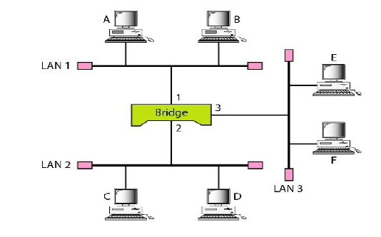

* + 1. Immediately after bridge is turned on.

(4 marks)

* + 1. After A has transmitted a frame to D.

(4 marks)

* 1. What is the different between unicast, multicast and broadcast addresses?

(3 marks)

* 1. Give two advantages of IPv6 addresses compared to IPv4 addresses.

(4 marks)

* 1. A company is assigned a block of IP addresses staring with 192.56.65.0/25. Management decides to split IP block into 4 equal subnets and assign them to different departments in the company.
     1. Use host id part of the IP block, 192.56.65.0/25 to figure out number of addresses in the block.

(3 marks)

* + 1. How many addresses can be given for each subnet?

(1 mark)

* + 1. Calculate first and last address of each subnet.

(12 marks)

* + 1. State the network address for each subnet.

(2 marks)

* 1. State two protocols used in email service.

(2 marks)

* 1. State which protocols can be used for step 2, 5, 8 of the mail transfer architecture shown in the figure below.

(9 marks)

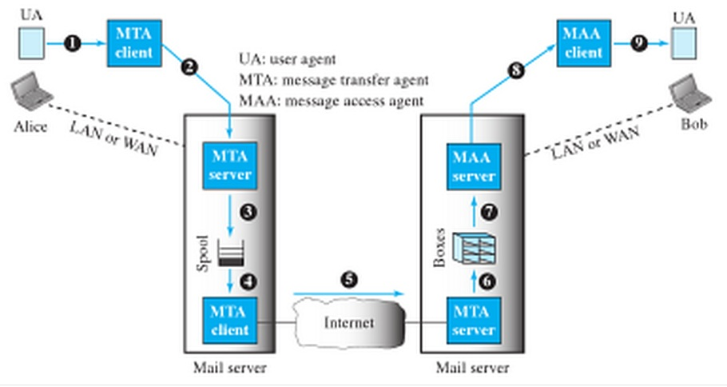

* 1. VPNs are commonly used in organizations to accomplish remote network connectivity. Answer following questions regarding VPNs.
     1. State in simple words, what is a VPN?

(3 marks)

* + 1. Name two advantages in using VPNs.

(4 marks)

* 1. DCHP stands for dynamic host configuration protocol.
     1. What is the purpose of using DHCP?

(2 marks)

* + 1. Briefly explain the operation of DHCP.

(5 marks)

* 1. A client in ku.nibm.lk wants to communicate with the server hosting ce.pdn.ac.lk website.
     1. State the names of two resolution methods which can be used to resolve IP of the required server.

(3 marks)

* + 1. Write down how IP address of the server is resolved using one of the resolution methods given above.

(10 marks)

* 1. WLANs can configured either one of two configurations as, Ad-hoc network or infrastructure.
     1. Briefly explain difference between Infrastructure network and Ad-hoc network.

(3 marks)

* + 1. IEEE 802.11 is the initial IEEE standard for WLANs. Write down three more WLAN standards defined by IEEE.

(3 marks)

* + 1. Arrange them in the order of increasing data rate.

(6 marks)

* 1. State two routing protocols used in present day networks.

(4 marks)

* 1. What are the routing algorithms used in two routing protocols you stated in previous answer?

(4 marks)

* 1. Draw the routing table for the router R1 in the network diagram shown in the figure.

(12 marks)

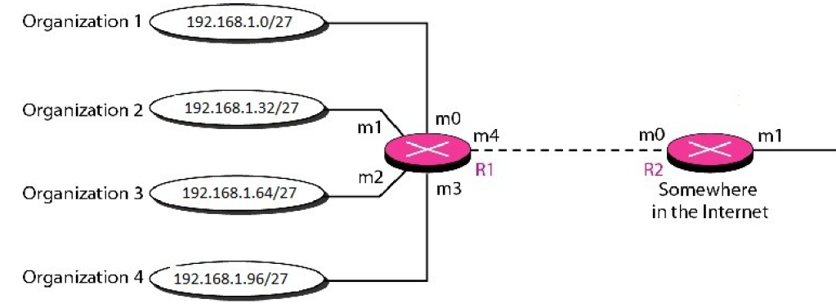

* 1. Routing table for R2 can be made smaller than the routing table of R1. Draw the routing table for R2.

(5 marks)